Math 8 Application 13 Name ________________________
Show all your work!

1. Circle the letter that represents the approximate location on the number line of $\sqrt{67}$.  A B C D  0 5 10 15 | 2. Simplify without a negative exponent:  6⁻³ = | 3. Solve for x:  x² = 361
4. Write in scientific notation.  0.000874 | 5. Write the product in scientific notation.  (6.8 ∙ 10³)(3 ∙ 10²) = | 6. Solve for x.  13x – 15 = 5x + 9
7. What type of transformation of Figure A resulted in Figure B?  A B | 8. Find the length of side a below.  8 in. a  10 in. | 9. Find the measure of angle b.  72˚  b
10. Put the following numbers in order from smallest to largest.  .25, 2/5, 30%, 2.5 | 11. Estimate the quotient below.  48,624 ÷ 840 | 12. Write as a fraction in simplest form: .7272….
13. James made a pattern with chips as shown below. Write an equation for the function.  Stage 1 Stage 2 Stage 3 | 14. Graph the first nine steps.  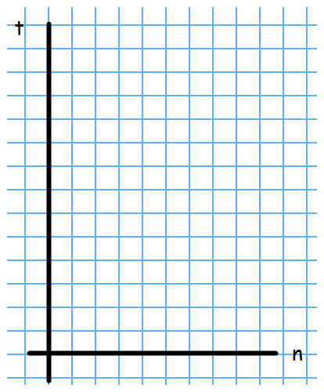 | 15. Complete the table.
   |  | o
   | o | o o
  o | o o | o o
  Step Number | Total dots
  0
  1
  2
  10
  20
16. What is the sale price of a pair of $75 jeans that is marked 30% off? | 17. Find the volume of a round swimming pool with a radius of 10 ft. and a height of 4 feet. | 18. James ate a 14 ounce bag of potato chips steadily throughout a 170 mile road trip. What was his eating rate in miles per ounce?
19. Juan’s quiz scores are 15, 14, 9, 10, and 11. What is the median of his quizzes? | 20. Sam ran 3600 meters and then walked 1500 meters. How many kilometers did he travel? | Number correct  5 minutes_______  Total___________

